Mini Project-Data Analysis Using Excel and Power BI
JEENA O -DAF-30
Topic -: Retail store sales Analysis
Use Link -: https://www.kaggle.com/datasets/ahmedmohamed2003/retail-store-sales-dirty-for-data-cleaning
Dataset contains the following fields -: Transaction ID, Customer ID, Category, Item, Price Per Unit, Quantity, Total Spent, Payment Method, Location, Transaction Date, Discount Applied
Goals -:
The goal of this analysis is to understand customer purchasing behaviour, improve sales performance, evaluate discount effectiveness, and optimize store operations by analysing sales transactions, product categories, payment methods, and purchase locations.

- What is the total revenue and total number of transactions over time.
- Which product categories generate the highest revenue.
- Which items are best -selling and least- selling.
- Do discounts affect the total sales and customer purchase behaviour.
- Which payment method is used the most by customer.
- How does Online performance compare with in store performance.
- Which customer spend the most, and what are their preferred categories.
- Identify monthly and yearly sales trends.
- Analyse average order value.
- Check if different categories sell more frequently during specific months.

Here the current data sheet -:
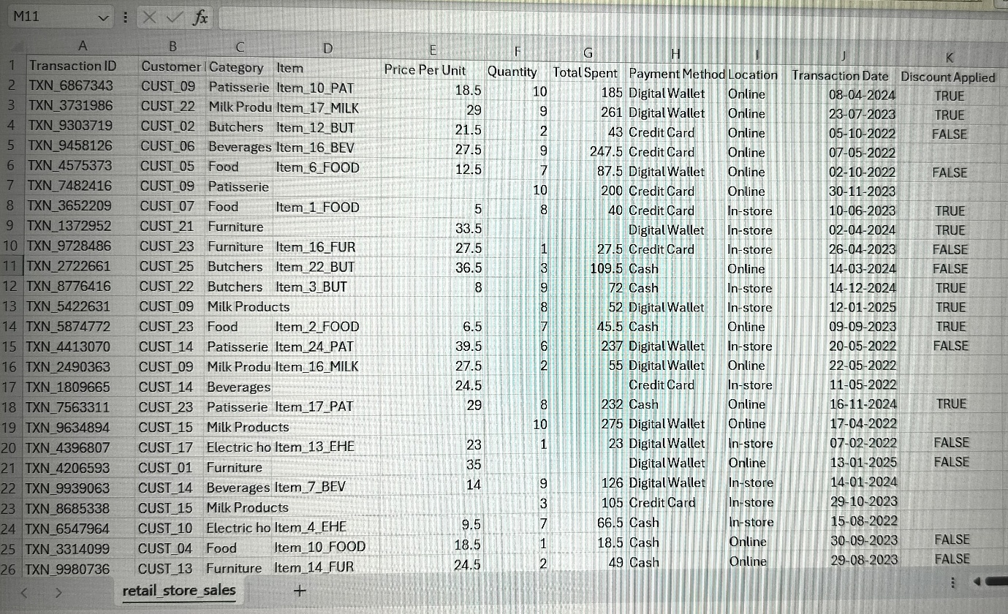
Total no of Rows = 12756
Total no of columns = 11
Steps – Data Cleaning and Data Transformation
- Remove duplicates from the dataset
No of Rows =12576
No of duplicates = 0
- Missing values were present in item, price per unit, quantity total spent, discount applied.
Using Methods –
- Identify how Many cells are missing the dataset, Use function = Count blank
Total missing values =7229
- Replacing missing values use function = IF (ISBLANK) , ”UNKNOWN”)
- = IF (ISBLANK (RANGE), AVERAGE, (RANGE)
QUANTITY / TOTAL SPENT=PRICE PER UNIT
- Use multiplication Formula = price per unit * quantity = total spent
use division formula = Quantity=total spent/price per unit
- Find and Replace the missing values
- Using Conditional formatting for UNKNOWN cell

Item
Item_10_PAT
Item_17_MILK
Item_12_BUT
Item_16_BEV
Item_6_FOOD
UNKNOWN
Item_1_FOOD
UNKNOWN
Item_16_FUR
Item_22_BUT
Item_3_BUT
UNKNOWN
Item_2_FOOD
Item_24_PAT
Item_16_MILK
UNKNOWN
Item_17_PAT
UNKNOWN
Item_13_EHE

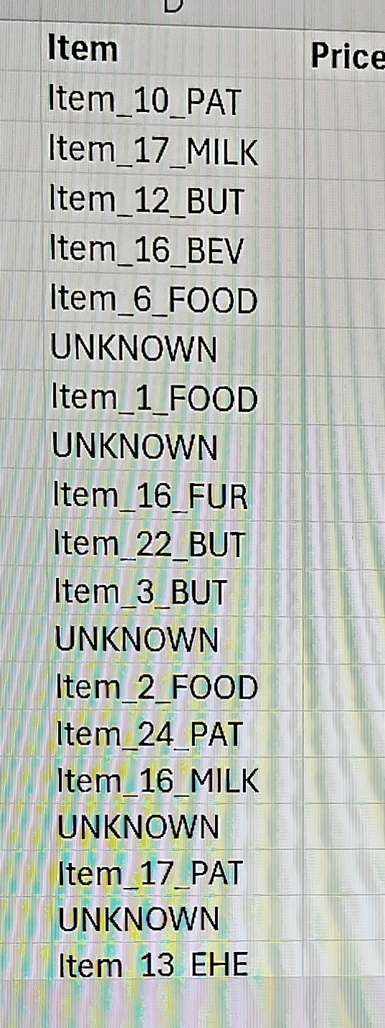

Here the cleaned dataset
